DRAFT for “International Handbook on ‘Tourism and Peace,’”
United Nations World Tourism Organization (UNWTO)
and Center for Peace Research and Peace Education,
Alpen-Adria-Universität, Klagenfurt, Austria, 2013.

Peace Tourism:
Peace as a Destination
By Edward W. Lollis

Abstract
Peace tourism is traveling to experience the places and activities that authentically represent peace stories and peacemakers of the past and present. Peace activities require varying degrees of planning and preparation. But peace places -- primarily monuments and museums -- are static and available to the tourist most any time.
Public awareness has not caught up with peace scholarship which increasingly defines "peace" as having both positive and negative themes, only one of which is the end of war. The vast number of peace themes -- 86 examples are named here -- confuses the public and prevents peace tourism from competing with simpler tourism "brands" like golf, beach resorts, U.S. Civil War history, African safaris, and theme parks.
Peace tourism nevertheless already exists in places like New York City and Hiroshima which have concentra-tions of peace monuments and museums. On a national level, an abundance of peace monuments and museums indicates that the ten countries most likely to benefit from peace tourism development (on a per capita basis) are Israel, New Zealand, the Netherlands, Switzerland, Austria, the United Kingdom, Norway, the USA, Canada, and Belgium -- in that order.
A case study is presented to demonstrate that peace tourism can also take place on a regional scale. A 360 mile (583 kilometer) highway corridor in the United States of America and Canada contains 100 peace monuments (including 15 “museums for peace”) and “authentically represents” ten different peace stories and at least 36 notable historic peacemakers. Similar corridors also exist elsewhere.
This paper concludes that many cities and corridors with concentrations of peace monuments are of sufficient interest to sustain peace tourism, provided that visitors appreciate the variety of peace themes which exist in any given city or region. To increase visitors' appreciation, the artists, city fathers, and museum curators respon-sible for peace monuments and museums should work together to promote peace tourism. Collectively, they could tell stories of peace and justice which are far greater than the sum of the individual parts.
***** ***** *****
This Handbook considers "Tourism and Peace" from many different perspectives. I assume that other authors address the relationships (both good and bad) between "peace" and any and all kinds of tourism. In this paper, I address "peace" not as the result of tourism but as the object or desired destination of one particular kind of tourism -- peace tourism.

I. What is peace tourism?
If tourism is travel for pleasure or education, what does it mean to travel to seek “peace” as a destination? Granted, some tourists travel to find peace in the sense of rest, repose, or enlightenment (“getting away from it all”). But I wish to consider traveling to see and experience peace in the same way that others travel to see and experience, for example, sports, nature, music, art, and so forth -- even war. How does the tourist travel to see or experience war? Unless he or she is a mercenary, the answer is vicariously, i.e. by visiting battlefields, reenactments, and war museums. Can tourists not travel to see and experience peace in the same way?
The National Trust for Historic Preservation in the United States defines heritage tourism as “traveling to experience the places and activities that authentically represent the stories and people of the past" and defines cultural heritage tourism as “traveling to experience the places and activities that authentically represent the stories and people of the past and present."
By modifying the latter definition only slightly, we can say:
Peace tourism is traveling to experience the places and activities that authentically represent peace stories and peacemakers of the past and present.
One might wonder exactly how peace tourists can travel to experience peace places and activities of the past and present. Based on the definition of peace tourism, this table suggests examples of some of the things a tourist might do during a peace tourism excursion:
By definition, peace tourism is traveling ...
 | ... to experience places ... | ... to experience activities ...
... that authentically  represent peace stories  & peacemakers of the  past (i.e. Peace History) | Visit peace monuments  Visit museums for peace  Visit the sites of historic peace events  Visit peace art in galleries & museums | Celebrate peace holidays  Celebrate peace anniversaries  Study historic peacemakers  Attend peace history events  Attend lectures & seminars
... that authentically  represent peace stories  & peacemakers of the  present (i.e. Peace Issues) | Attend peace studies programs  Visit places where injustice occurs  Visit UN & other official agencies  Visit projects of non-govt. organizations | Meet with peace activists  Stay in peace activists' homes  Attend peace workshops & festivals  Take part in peace actions & protests  Lobby government officials
Peace activities require varying degrees of planning and preparation. They are events comparable to theater performances and sports events in that the tourist must plan to be at the right place at the right time. Anni- versaries occur only once a year, and meetings with individuals or local organizations usually require pre- arrangement. Nevertheless, some tourists travel as part of well organized groups, and many local organizations advertise their activities and welcome out-of-town participants. So it is not inconceivable that a day or week of "peace tourism" might include several of the time specific activities suggested by the foregoing table.
Throngs of tourists visit Berlin, Geneva, Hiroshima, and UN Headquarters in New York City, but how many call themselves "peace tourists"? Probably not very many. The public visits battlefields, golf courses, cathedrals, opera houses, and football stadia, and doing so in organized groups has created commercial opportunities for tourism operators. But "peace" is simply not a “brand” that the public recognizes today.
Peace places are static and available to the tourist most any time. This paper focuses on monuments and museums which exist in public space and can be visited most any day of the year without prearrangement.

II. What are peace monuments and museums?
There are several answers to this question.
The first answer is easy -- most any monument or museum named for "peace." But this answer is deceptive. "Peace" is a concept and ideal recognized by many different cultures, and the word "peace" has been used for many different meanings. What Ronald Dworkin said about "religion" applied equally well to "peace:" "[It is] an interpretive concept. That is, people who use the concept do not agree about precisely what it means: When they use it they are taking a stand about what it should mean." Does the tranquil Japanese "Peace Garden" at UNESCO headquarters in Paris have the same meaning as the aggressive "Goddess of Peace" (who is breaking a sword and stomping on the head of a soldier) in Karlstad, Sweden?
Even though the aspiration for "peace" may be universal, peace tourists soon learn to encounter wide variation in the many meanings and interpretations of the word "peace." And this accounts for some of the fascination of peace tourism.
The second answer is to include monuments and museums which represent the same values as "peace" but, for one reason or another, do not happen to include "peace" in their names. In 1913, the "Peace Palace" was dedi-cated in The Hague to be home of the Permanent Court of Arbitration, and, in 1952, United Nations head-quarters opened in New York City without being named for "peace" but is certainly no less a peace place than the palace in The Hague. In Hiroshima, many monuments and museums related to nuclear destruction in 1945 are named for "peace" (heiwa), but in Europe, the many monuments and museums related to the Holocaust are not specifically named for "peace" but represent "peace" in the very same way as "peace" monuments in Japan.
The third answer is to consider some of the various meanings of the word "peace," the most obvious being the absence of war. Many peace monuments have been constructed to celebrate the cessation of hostilities and the promise of prosperity and progress after war. The phrase "peace museum" traditionally connotes an "anti-war" museum which exhibits the evils of war and the benefits of "non-war."
But modern scholarship has tended to define "peace" ever more broadly. As noted by Professor Ikuro Anzai (founder of the Kyoto Museum for World Peace at Ritsumeikan University in Japan), "peace" is no longer defined as the "absence of war" but as the "absence of violence," and violence in this context is understood as "causes to prevent people from making full use of their ability."
"Peace monuments" represent this expanded definition in two different ways. Some peace monuments decry not only war but genocide, colonialism, racism, or any of the many other evils which prevent the attainment of human potential. To simplify, we might say that these monuments emphasize negative themes of peace. They deplore the tragedies of the past, warn about the causes of the tragedies, and project the powerful message of "never again." The other kind of peace monument celebrates the positive themes of peace -- human rights, reconciliation, the acts of individual peacemakers (or peace heroes), and so forth.
The following table lists 43 examples of each of the two kinds of peace monuments. The two lists are long but incomplete. They reflect Johan Galtung's 1964 definitions of negative peace ("absence of violence, absence of war") and positive peace ("the integration of human society").

Some Positive & Negative Themes
Examples of Positive Peace  “Integration of Human Society” |  | Examples of Negative Peace  “Absence of Violence, Absence of War”
Abolition  Arbitration  Civil Rights  Democracy  Disarmament  Economic Development  Education  Emancipation  Environmentalism  Food & Shelter  Gay Rights  Golden Rule  Human Rights  Indigenous Peoples  Integration  International Friendship  International Law  Job Training  Justice  Liberation  Marriage Equality | Nobel Peace Prize  Non-Violence  Pacifism  Peace After War  Peace Philanthropy  Peace Poles  Peace Treaties  Peacemakers / Heroes  Public Health  Quakers / Mennonites  Racial Diversity  Reconciliation  Red Cross / Red Crescent  Religious Freedom  Resistance  Sister Cities  Social Justice  Tolerance  UN Agencies  Women's Rights  Workers' Rights  World Peace | Abuse of Power  Aggression  Apartheid  Arms Race  Berlin Wall  Atrocity  Chemical Warfare  Child Abuse  Climate Change  Colonialism  Communism  Corruption  Crime & Gangs  Discrimination  Disease  Drug Trade  Eugenics  Fascism / Nazism  Genocide / Removal  Holocaust / Shoah  Hunger | Inequality  Injustice  Intolerance  Lack of Water  Landmines  Nuclear Weapons  National Occupation  9/11 Attack  Pollution  Poverty  Racism  Repression  Slavery  Species Extinction  Terrorism  Totalitarianism  Torture  War  War Crimes  Unemployment  Unfair Prosecution  Violence
Like all other monuments, museums are physical, permanent, and symbolic. But they are also living institu-tions with complexity, multiple programs, and the capacity to adapt to changing circumstances. In 2005, the International Network of Peace Museums changed its name to International Network of Museums for Peace. Although INMP's institutional membership and out-reach programs have not yet greatly expanded in keeping with the broader definition, the concept of "museum for peace" nevertheless brings hundreds of museums not specifically named for "peace" (but related to any of the negative or positive themes listed in the foregoing table) under the broad embrace of peace tourism.
III. What cities are most likely for peace tourism?
Peace tourism already happening in cities which have numerous peace monuments and museums for peace: Atlanta, Belfast, Berlin, Chicago, Geneva, Hiroshima Jerusalem, London, Nagasaki, New Delhi, New York City, Ottawa, Philadelphia, The Hague, Tokyo, and Vienna.
More than a dozen cities in five countries have recently created peace trails by listing peace monuments and museums in a brochure or website for the information of tourists: Amsterdam, Atlanta, Bradford, Bristol, Cambridge, Christchurch, Coventry, Geneva, Indianapolis, Leeds, London, Manchester, Montgomery, Rotterdam, and Wellington.
In the United States, long-distance motor or bicycle trails have been established to trace the routes of the 1838-1839 Cherokee "Trail of Tears," the circa 1850 "Underground Railroad" of escaping slaves, and the 1965 voting rights march from Selma to Montgomery, Alabama.
Michelin guides have ranked principal sights with three, two, or one stars. Here are a dozen peace tourism destinations (cities) which, in the author's opinion, deserve three stars ("Worth a journey"):
Top Dozen  Peace Tourism Destinations  (Cities) | 44 Examples of Notable  Peace Monuments & Museums for Peace  (with year of creation) | Approx.  # of Peace  Monuments | Including  this # of  Museums
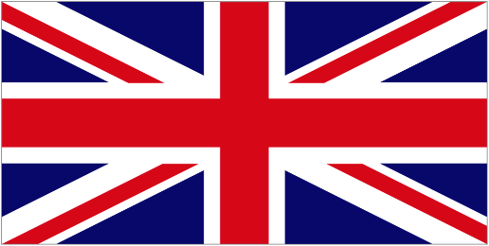 London, England | 1945 - Housmans Bookshop, Peace House  1968 - Mahatma Gandhi Statue, Tavistock Square  2012 - “Peace Trails Through London” | 92 | 2
Washington, DC, USA | 1910 - Organization of American States (Carnegie)  1993 - US Holocaust Memorial Museum  2011 - Martin Luther King, Jr., National Memorial  2012 - US Institute of Peace (USIP) | 74 | 13
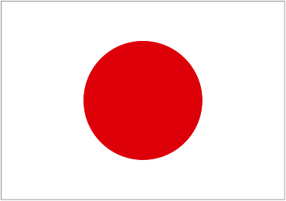 Hiroshima, Japan | 1954 - Hiroshima Peace Memorial Park  1955 - Hiroshima Peace Memorial Museum  2002 - National Peace Memorial Hall for the Atomic Bomb Victims | 73 | 4
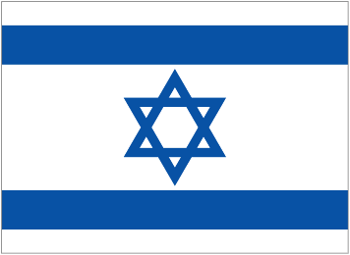 Jerusalem, Israel &  Bethlehem, West Bank | 1953 - Yad Vashem Historical Memorial  2000 - “Tent of Nations,” Daher's Vineyard  2001 - Bethlehem Peace Centre  2005 - Holocaust History Museum, Yad Vashem  2008 - Tolerance Park & Monument  2014? - Museum of Tolerance (Simon Wiesenthal Center) | 65 | 4
New York City, NY, USA | 1952 - United Nations Headquarters  1997 - Museum of Jewish Heritage - Living Memorial to the Holocaust  2004 - Museum of Tolerance New York (Simon Wiesenthal Ctr) | 64 | 20
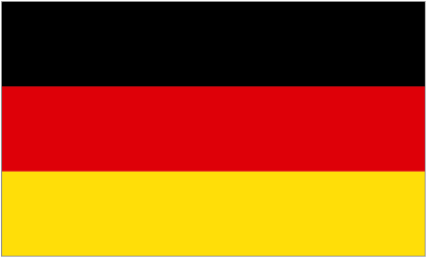 Berlin & Potsdam, Germany | 1793 - “Goddess of Peace,” Brandenburger Tor  1962 - Museum Haus am Checkpoint Charlie  1982 - Anti-Kriegs Musuem / Anti-War Museum  2001 - Judisches Museum / Jewish Museum Berlin  2005 - Memorial to the Murdered Jews of Europe | 62 | 9
Nagasaki, Japan | 1955 - Nagasaki Peace Park  1955 - Nagasaki Atomic Bomb Museum  2002 - National Peace Memorial Hall for the Atomic Bomb Victims | 51 | 3
Atlanta & Decatur, GA, USA | 1968 - Martin Luther King, Jr., Center for Nonviolent Social Change  1980 - Martin Luther King, Jr., National Historic Site  1982 - Jimmy Carter Library & Museum | 50 | 8
Chicago, Illinois, USA | 1931 - Baha’i House of Worship for North America  1957 - DuSable Museum of African American History  1967? - Jane Addams Hull-House Museum | 31 | 7
Tokyo & Yokohama, Japan | 1976 - Display House of the Daigo Fukuryu-Maru  1983 - “Peace Boat” (SS Topaz), Yokohama  1992 - Kawasaki Peace Museum, Kawasaki  1993 - Peace Museum of Saitama, Saitama  2002 - Centre of the Tokyo Raid & War Damage | 29 | 10
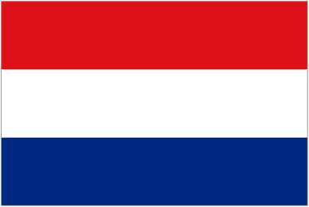 The Hague, Netherlands | 1913 – Vredespaleis / Peace Palace (Carnegie)  1995 - Yi Jun Peace Museum  2012 - Peace Palace Visitors Centre | 24 | 5
Geneva, Switzerland | 1936 - Palais des Nations / Palace of Nations  1946 - League of Nations Museum  1988 - International Red Cross & Red Crescent Museum | 18 | 2
The 44 examples in the foregoing table represent nine positive peace themes (civil rights, international law, indigenous peoples, Nobel Peace Prize, peacemakers, Red Cross, tolerance, UN agencies, and world peace) and eight negative peace themes (Berlin Wall, discrimination, Fascism/Nazism, Holocaust, nuclear weapons, national occupation, 9/11, and racism).
Four of the 12 cities in the foregoing table (Geneva, New York City, The Hague, and Washington) host multiple international organizations. Four of the cities (Berlin, Hiroshima and Nagasaki, and Tokyo) are the sites of horrendous tragedy. And four (Atlanta, Chicago, Jerusalem, and London) make the list largely as the result of notable peacemakers who lived or worked there.
IV. What countries are most likely for peace tourism?
Peace places and peace activities are not evenly distributed around the world. The following table attempts to estimate the potential for peace tourism in 30 selected countries. The data presented are extracted from on-line data sets (which can be easily accessed by clicking links embedded in the on-line version of this table at http://www.peacepartnersintl.net/tourism.htm). Each source is presumed to be reliable, but the results are inconsistent because definitions are imprecise and because researchers have sought information in different ways.
The table contains data for the number of peace museums, museums for peace, human rights museums, "sites of conscience," peace monuments, Holocaust memorials and museums, and peace studies programs in each of the 30 countries. The totals at the right side of the table estimate of the number of “places and activities that authentically represent peace stories and peacemakers of the past and present.”
30 Selected  Countries | Peace  Museums | Museums  for  Peace | Museums  for  Peace | FIHRM  Partners &  Supporters | ICSC  Founders  & Inst.  Members | Peace  Monuments | Holocaust  Memorials  &  Museums | College &  University  Peace  Studies  Programs | Total  Places  (despite  double  counting) | Popu-  lation  (1000's) | Persons  per  Place | Places Include  (both positive &  negative examples)
Data Sources  Go on-line  to see data sets. | Wikipedia | K.Yamane  (World)  K.Yamane  (Japan) | Author's  Website | Federation  of Intl.  Human Rts.  Museums  (FIHRM) | International  Coalition  of Sites of  Conscience  (ICSC) | Author's  Website | Wikipedia | West-  moreland  -White | Calcu-  lation | Wikipedia | Calculation  (used to  rank order  this table)
Israel | - | - | 4 | - | - | 158 | 7 | 1 | 170 | 8,002 | 47,070 | Yad Vashem
New Zealand | - | - | - | 2 | - | 36 | - | - | 38 | 4,467 | 117,553 | Nuclear Free Zone
Netherlands | 5 | 9 | 18 | 1 | - | 65 | 5 | - | 103 | 16,784 | 162,951 | Peace Palace
Switzerland | - | 4 | 5 | - | - | 40 | - | - | 49 | 8,037 | 164,020 | UNO Geneva
Austria | 1 | 3 | 5 | - | - | 35 | 3 | 1 | 48 | 8,489 | 176,854 | UNO Vienna
UK | 2 | 3 | 14 | 16 | 1+4 | 266 | 4 | 5 | 315 | 63,182 | 200,578 | Reformers
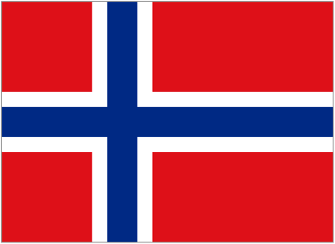 Norway | 1 | 3 | 3 | 2 | 0+1 | 12 | - | 1 | 23 | 5,051 | 219,609 | Morokulien
USA | 5 | 18 | 227 | 2 | 6+67 | 958 | 35 | 82 | 1,400 | 315,779 | 225,556 | UN Headquareters
Canada | - | - | 13 | - | 0+3 | 126 | 3 | 6 | 151 | 35,056 | 232,159 | UN Peacekeeping
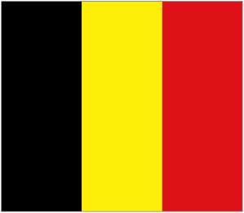 Belgium | 2 | 3 | 6 | - | 0+2 | 25 | 1 | - | 39 | 11,151 | 285,923 | Edith Cavell
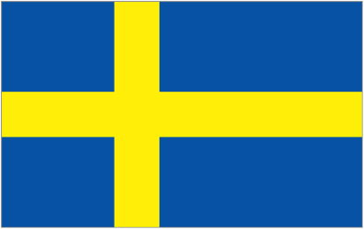 Sweden | 3 | 2 | 4 | - | 0+1 | 13 | 1 | 2 | 26 | 9,567 | 367,962 | Morokulien
Ireland | - | - | - | - | - | 9 | - | 3 | 12 | 4,585 | 382,083 | Reconciliation
Japan | 20 | 34 | 29 | - | 0+1 | 201 | - | - | 285 | 127,340 | 446,807 | Hiroshima/Nagasaki
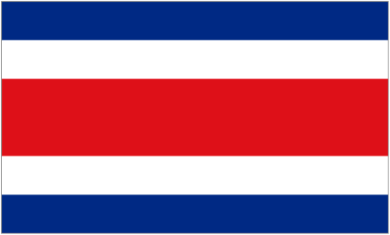 Costa Rica | - | 1 | 1 | - | - | 7 | - | 1 | 10 | 4,667 | 466,700 | UN University
France | 1 | 4 | 20 | 2 | 0+1 | 52 | 54 ?! | 2 | 136 | 65,619 | 482,493 | UNESCO
Germany | 5 | 12 | 27 | 1 | 0+1 | 114 | 3 | 1 | 164 | 82,029 | 500,177 | Nazi desertions
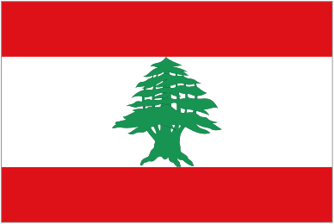 Lebanon | - | - | - | - | 0+1 | 5 | - | 1 | 7 | 4,324 | 617,714 | Sabra & Shatilla
Australia | - | - | 1 | 2 | 0+1 | 26 | 2 | 4 | 37 | 23,009 | 621,865 | Nobel Peace Walk
Poland | - | 5 | 13 | 1 | 0+3 | 12 | 7 | - | 41 | 38,534 | 939,854 | Holocaust
Greece | - | - | 1 | - | - | 7 | 1 | - | 9 | 10,815 | 1,201,667 | Olympic Games
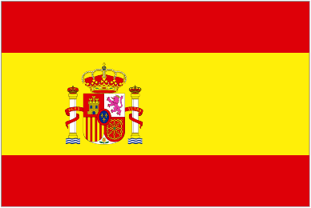 Spain | 2 | 2 | 4 | - | 0+4 | 24 | - | 1 | 37 | 47,060 | 1,271,892 | Guernika
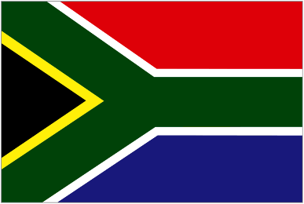 South Africa | - | 1 | 10 | - | 2+5 | 18 | 3 | - | 39 | 51,771 | 1,327,462 | Apartheid
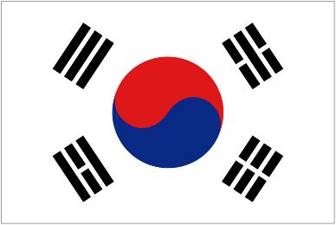 South Korea | 1 | 6 | 5 | - | 0+1 | 24 | - | - | 37 | 50,004 | 1,351,459 | Demilitarized Zone
Italy | 2 | 2 | 8 | 1 | 1+4 | 23 | 3 | - | 44 | 59,500 | 1,352,272 | Pax Romana
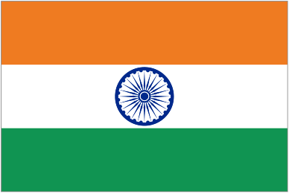 India | 2 | 3 | 11 | - | 0+2 | 52 | - | - | 70 | 1,210,193 | 1,728,847 | Mahatma Gandhi
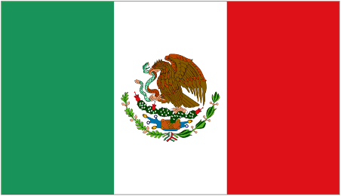 Mexico | - | - | 1 | 2 | 0+3 | 24 | - | - | 30 | 112,337 | 3,744,567 | Amistad/Friendship
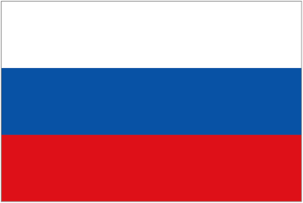 Russia | - | - | 5 | - | 2+4 | 24 | - | - | 35 | 143,370 | 4,096,286 | Gulags
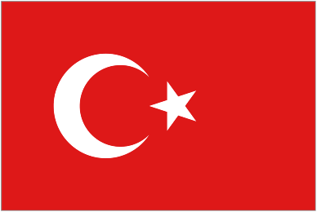 Turkey | - | - | - | - | - | 10 | - | 1 | 11 | 75,627 | 6,875,181 | Atatürk's "Peace at home"
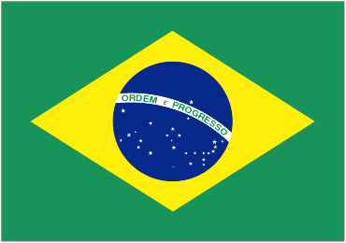 Brazil | - | - | 3 | - | 0+2 | 11 | 1 | - | 17 | 193,947 | 11,408,647 | Tortura Nunca Mais
China | 1 | 12 | 4 | - | - | 19 | - | - | 46 | 1,354,040 | 29,435,652 | Japanese Aggression
30 Country Total | 53 | 127 | 442 | 32 | 12+110=122 | 2,396 | 133 | 112 | 3,417 | 4,144,336
30 Country Average | 1.8 | 4.2 | 14.7 | 1.1 | 4.1 | 79.9 | 4.4 | 3.7 | 113.9 | 138,145 | 1,212,862
212 Country Total | - | 27 | 49 | 14 | 5+47=52 | Many | 14 | - |  | 2,869,080
242 = World Total | 53 | 154 | 491 | 46 | 17+157=174 | 2,396+Many | 147 | 112 |  | 7,013,416
30 Selected  Countries | Peace  Museums | Museums  for  Peace | Museums  for  Peace | FIHRM  Partners &  Supporters | ICSC  Founders  & Inst.  Members | Peace  Monuments | Holocaust  Memorials  &  Museums | College &  University  Peace  Studies  Programs | Total  Places  (despite  double  counting) | Popu-  lation  (1000's) | Persons  per  Place | Places Include  (both positive &  negative examples)
The table indicates that the ten countries most likely to benefit from peace tourism development (on a per capita basis) are Israel, New Zealand, the Netherlands, Switzerland, Austria, the United Kingdom, Norway, the USA, Canada, and Belgium -- in that order.
V. Can peace tourism thrive on a regional scale?
The foregoing sections have named a number of cities and entire countries where peace tourism takes place (or could take place) because of peace monument and museum concentration. But peace monuments and museums also exist in small places, and indeed they are sometimes scattered over wide areas.
A case study is now presented to explore if peace tourism can also take place on a regional scale. This study explores a hypothetical example of peace tourism where "peace tourists" (travelling independently or as part of organized groups) would forego visiting a city of peace monument concentration and would move (by car or bus) from town to town over a period of several days or even a week at a time. This case study is hypothetical. The author and his wife are probably the only persons to have followed the itinerary outlined here.
As shown on the adjacent map, the study area is a 360 mile (583 kilometer) highway corridor in the United States of America and Canada. The area contains 100 peace monuments (including 15 “museums for peace”) that “authentically represents” ten different peace stories and at least 36 notable historic peacemakers. If a peace tourist were to stop at each and every monument, he or she would be stopping, on average, every 3.6 miles (5.8 km).

The southern edge of the study area borders the Ohio River, and its northern edge borders the Detroit River. Ever since the American Revolution, the latter river has been part of the international border. Before the American Civil War, the former river was the boundary between slave and free states. Could these geographic facts influence what the "peace tourist" would see when traveling from one river to the other?
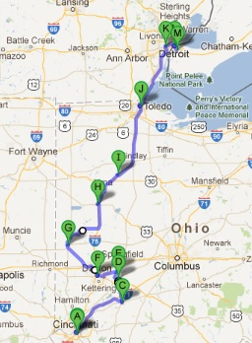 |  |  | M Windsor, Ontario  --- Detroit River ---  L Detroit, Michigan  K Dearborn, Michigan  J Toledo, Ohio  I Bluffton, Ohio  H Wapakoneta, Ohio  G Greenville, Ohio  F Dayton, Ohio  E Yellow Springs, Ohio  D Wilberforce, Ohio  C Wilmington, Ohio  B Cincinnati, Ohio  --- Ohio River ---  A Newtown, Kentucky

The study area has never been ravaged by war (except for "Indian Wars" in the late 18th century when settle-ments were few and far between). The area contains no huge city, no national park, no "world class" tourist attraction like Disneyland or Las Vegas. Its largest cities -- Detroit, Cincinnati, and Toledo -- are only the 18th, 64th, and 67th largest cities in the United States. Windsor is only the 16th largest metropolitan area in Canada.
Yet the study area is not without many points of "peace tourism" interest. It contains the world's largest Western style peace bell, the only "peace museum" in North America, the only display of Hiroshima artifacts outside Japan, the site of an important 1795 peace treaty, the first mosque in North America to use classic Islamic architecture, not one but three nationally recognized museums -- the National Underground Railroad Freedom Center, the National Afro-American Museum and Cultural Center, and the Arab American National Museum -- the B-29 bomber which destroyed Nagasaki, a town named for British abolitionist William Wilberforce, and a small Mennonite university (Bluffton) which arguably has the highest per capita concentration of peace monuments of any place on earth.
To some extent, therefore, the study area was chosen because it contains some important points of peace interest. But it is not unique. Comparable areas certainly exist, for example Civil Rights sites in the American South and Holocaust sites in Germany, Poland, and other countries of Eastern Europe. And the author is con-fident that he could identify many more corridors in California, eastern North America, the United Kingdom, continental Europe, New Zealand, India, Israel/Palestine, and Japan which would contain an equal (or even greater number) of sites which could interest the hypothetical "peace tourist."
One of the "problems" identified by the case study is that the traveling public probably does not recognize that so many peace themes have something in common -- the "interpretive concept" of "peace.” Monuments use symbols, inscriptions, and physical presence to preserve an idea or event as interpreted by someone in the more or less distant past. The stories monuments tell are never complete and -- as vividly demonstrated in the study area -- are scattered geographically. So it takes some effort on the part of the peace traveler to keep track of different peace stories.
The study area’s 100 peace monuments and museums represent the following ten peace stories (listed here in historic order):
-- Native Americans, peace treaties, and removal.
-- Slavery, abolition, and emancipation.
-- Education and institutional development.
-- US-Canadian friendship and unfortified boundary.
-- Holocaust and World War II.
-- Hiroshima, Nagasaki, and the atomic bomb.
-- Labor movement and workers' rights.
-- Afro-American emancipation and civil rights movement.
-- Immigration and ethnic diversity.
-- Recent conflicts: Vietnam, Iraq, and the “9/11” terrorist attack
Here, from south to north, is a summary of peace places in the study area:
-- At the southern end of the corridor, there are several monuments about slavery and emancipation from slavery, including an immense museum, the National Underground Railway Freedom Center (NURFC). Indeed, the so-called "underground railway" (an indistinct network of farms and safe houses through which escaped slaves found their way to freedom in Canada) is the single most important peace story in the study area, and 15 of the area’s 100 monuments are related to the underground railway. To the right and left of the corridor (but not exactly on the route shown here) are historic properties preserved to interpret the underground railroad. Near Windsor, Ontario, at the north end of the corridor, are two or more farmsteads preserved as outdoor museums to represent the goal of the slaves fleeing from bondage south of the Ohio River to freedom on the Canadian side of the Detroit River.
-- Part way up the corridor are three cities (Wilberforce, Yellow Springs, and Dayton) which made important contributions to civil rights and to the advancement of Afro-Americans.
-- A litte father north are two cities (Greenville and Wapakoneta) associated with Native American (Indoamerican) history and US Government removals of Native Americans to the West. In Wapakoneta, a private citizen has gather glacial boulders to construct an immense “Temple of Tolerance.”
-- Three cities at the northern end of the corridor (Toledo, Detroit, and Windsor) are heavily industrialized, and some of their monuments reflect the struggle for workers' rights.
-- On the Detroit River are three monuments constructed between 1930 and 1941 in celebration of peace since 1814 along what is recognized as the world's longest unfortified boundary. Alas, the remarkable record of the USA and Canada to coexist in harmony and with a minimum number of border restrictions is no longer the object of monument construction (with the exception of some "Gardens for Peace" further East occasioned by the recent bicentennial of the War of 1812).
-- The remaining peace monuments along the corridor from the Ohio River to the Detroit River represent a variety of peace themes and physical forms: World peace (9), peace art (9), individual peacemakers (9), civil rights (7), Martin Luther King, Jr. (6), personal peace (5), notable peace poles (5), Holocaust and anti-Semitism (3), atomic weapons (3), native Americans (3), pacifism (3), peace bells (3), peace trails (3), sister cities (3), Islam (2), Berlin Wall (2), labor movement (2), Mahatma Gandhi (2), peace parks and gardens (2), environ-mentalism (2), the 9/11 attack (2), and women's rights (2). Themes represented by a single monument (until more are identified) include Abraham Lincoln, the war in Iraq, the Viet-Nam War, and peace fountains.
The atomic bomb and peace art happen to find more monuments here that one would expect in Europe and elsewhere in North America. Otherwise, the list of themes noted above is typical of many other regions.
The study area also shows a typical variety of physical forms. As already noted, it boasts North America's one and only anti-war "peace museum" (the Dayton International Peace Museum) whose original raison d'etre is the Dayton Peace Accords which brought peace to Bosnia and Herzegovina in 1995. But the study area also has six other "museums for peace," three peace art galleries, two museum exhibits about peace themes, six historic houses which are open to the public and operate as museums, and two historic farmsteds open to the public.
The seven museums for peace are in Cincinnati (holocaust and underground railway), Dayton (peace), Dearborn (Arab-American culture and history), Detroit (Afro-American history and holocaust), and Wilberforce (Afro-American history). The three peace art galleries are in Bluffton, Dayton and Detroit. The two museum exhibits about peace themes are in Greenville (Peace Treaty of 1795) and Willmington (Hiroshima). The four historic houses which are open to the public and operate as museums are in Dayton (Afro-American history), Cincinnati (emancipation), Waynesville (Quaker history), and Wilberforce (Afro-American history). And the two farm-steads are both near Windsor (and both related to the underground railway).
The 100 monuments include six imports -- Cherry trees from Japan, an ancient Roman column, a segment of the Berlin Wall from Germany, a peace bell cast in France in 1999, and original French paintings from 1654 and 1840. One of the French paintings depicts the slave trade and is complimented by American paintings of 1845 and 1893 showing the same injustice.
Except for the paintings, the oldest peace monument in the entire study area was erectred in 1928, and the bulk of the monuments date from the 1980's (22), 1990's (11), and first decade of the 21st century (28). But Asian and European readers of this case history would be wrong to assume that the monuments are relatively new because everything is new in the "New World." Insofar as peace monuments are concerned, the very concept is relatively new, and the bulk of peace monuments in Asia and Europe are similarly dated.
The definition of peace tourism includes places and activities that authentically represent peacemakers of the past and present. The study area has monuments and/or museum displays preserving the memories of at least these 36 peacemakers (listed here in birth order):
Name | Dates | Peace Achievement
Cincinnatus | 519-430 BC | Resigned Roman dictatorship
Born in the 18th Century
Black Hoof | c1740-1831 | Advised other Indians to avoid “Tecumseh;s War”
Little Turtle | c1747-1812 | Ended 40 years of war by signing Greenville peace treaty
William Wilberforce | 1759-1833 | Led British effort to end slavery in 1833. Member of Parliament.
Lyman Beecher | 1775-1863 | Famous minister & abolitionist. Father of accomplished family.
Sir Thomas Buxton | 1786-1845 | Brewer, abolitionist & reformer. Member of Parliament.
Josiah Henson | 1789-1883 | Former slave. Settled in Ontario, Canada.
Frances Wright | 1795-1852 | Abolitionist & newspaper editor. Born in Scotland.
Horace Mann | 1796-1859 | “Father of the American public school system”
Levi Coffin | 1798-1877 | Quaker abolitionist. Ran Underground RR “Grand Central Station”
Born in the 19th Century
James Bradley | c1800-? | Former slave. Captured in Africa. Bought his own freedom.
Abraham Lincoln | 1809-1965 | President of USA. Issued Emancipation Proclamation in 1863.
Isaac Harvey | 1809-1883 | Quaker farmer. Visited President Lincoln to end slavery.
Daniel Alexander Payne | 1811-1893 | Methodist bishop & educator. Founded Wilberforce College.
Harriet Beecher Stowe | 1811-1896 | Abolitionist. Wrote influential novel “Uncle Tom’s Cabin.”
Martin Robinson Delaney | 1812-1885 | Physician. Officer in US Army. "Father of Black Nationalism."
John Freeman Walls | 1813-1911 | Former slave. Settled in Ontario, Canada.
Elizabeth Blackwell | 1821-1910 | Born in England. First female medical graduate in USA.
Charles Young | 1864-1922 | West Point graduate. 1st Black national park superintendent.
Mahatma Gandhi | 1869-1948 | Led nonviolence in South Africa & India. Later sculpted in Ohio.
Nancy Brown | 1870-1948 | Newspaper columnist. Celebrated US-Canadian friendship.
Paul Lawrence Dunbar | 1872-1906 | Black poet & playwright. Built house in Dayton, Ohio.
Arthur Ernest Morgan | 1878-1975 | Engineer & educator. Founded Community Service Inc. (CSI).
Born in the 20th Century
Theodore (Ted) Berry | 1905-2000 | First African-American mayor of Cincinnati, Ohio
Charles Brooks | 1915-1977 | Labour leader in Windsor, Ontario. Assassinated by opponent.
Barbara Leonard Reynolds | 1915-1990 | Quaker. Founded World Friendship Center in Hiroshima, Japan.
Masahisa Goi | 1916-1980 | Philosopher. Started peace poles (“May Peace Prevail on Earth”).
Charles Howard Wright | 1918-2002 | Physician. Opened Museum of African-American Hist. in Detroit.
James W. Bristah | 1919-2008 | Minister. Opened Swords into Plowshares Peace Center in Detroit.
Charles H. Rosenzveig | 1920-2008 | Polish Rabbi. Opened Holocaust Memorial Center in Detroit.
Coretta Scott King | 1927-2006 | Wife of MLK, Jr. Attended Antioch College in Yellow Springs.
Martin Luther King. Jr. | 1929-1968 | Minister & civil rights leader. Assassinated in Memphis, Tennessee
Richard Holbrooke | 1941-2010 | Diplomat. Negotiated Dayton Peace Accords to end war in Bosnia.
Wayne Carlisle | 1941-Alive | Businessman. Erected 1999 World Peace Bell in Newport, KY
Sadako Sasaki | 1943-1955 | Hiroshima victim. Tried to fold 1,000 peace cranes before death.
A. Zziz Chowdhury | ?-Alive | Librarian from Bangladesh. Donated Peace Clock to Windsor, ON

VI. Conclusions
-- Tourists travel to play golf, to take adventure tours, and to visit battlefields, but relatively few tourists currently seek peace as a destination. An obvious reason is that the public is largely unaware of the tourism value of peace places and peace activities.
-- The public is in fact largely unaware of "peace" as a category of tourism interest and of the many different meanings and themes of “peace.” To create “peace tourism,” the public needs to become increasingly aware of the many meanings of “peace” and of the many interesting “peace tourism” options.
-- There is virtually no peace tourism industry today. The existing tourism industry (airlines, hotels, tourism promotion agencies, and travel writers) overlooks "peace" as a tourism destination. Peace places and activities are rarely advertised or shown in popular guide books.
-- University peace studies departments, peace activist associations, and other organizations which make a conscious effort to promote peace and justice do so largely within their own boundaries and in isolation from the traveling public.
-- Public awareness has not caught up with peace scholarship which increasingly defines "peace" as having both positive and negative themes, only one of which is the end of war. The vast number of peace themes confuses the public and prevents peace tourism from competing with simpler tourism "brands" like golf, beach resorts, U.S. Civil War history, African safaris, and theme parks.
-- Peace tourism nevertheless already exists (knowingly or unknowingly) in places like New York City and Hiroshima which have concentrations of peace monuments and museums.
-- On a national level, an abundance of peace monuments and museums indicates that the ten countries most likely to benefit from peace tourism development (on a per capita basis) are Israel, New Zealand, the Nether-lands, Switzerland, Austria, the United Kingdom, Norway, the USA, Canada, and Belgium -- in that order.
-- The case study proves that there are enough peace monuments and museums in one short (360 mile) stretch of highway to occupy a serious "peace tourist" for several days. Similar corridors exist elsewhere.
-- The 18 museums and 82 other peace monuments in the study area collectively illustrate the history of mankind's striving in multiple ways to bring about peace and justice for all, and the peace stories they tell contribute to an overall appreciation of "peace" which is far greater than the sum of their individual stories.
-- The study area is not unique. Doubtlessly, there are many other areas in the USA and abroad where other peace monuments and museums (representing different peace stories) could alkso become the foundation of peace tourism..
-- Especially when interpreted by an experienced facilitator or guide, these "peace places" could instruct, inspire, and/or entertain a variety of different age and interest groups: Children, students, history buffs, church groups, peace activists, retirees, and others.
-- Until peace tourism becomes established, tourists will continue to use the same roads and hotels to seek and find forms of tourism with which they are familiar (or which have been sold to them by professional marketers), such as beaches, boating, theme parks, music festivals, competitive sports, gun shows, the Civil War, military reenactments, air shows, and battlefields. The overall effect of such forms of tourism is to help perpetuate the culture of war or violence.
VII. Recommendations
-- Find ways for stakeholders of the tourism industry and of peace organizations to interface and create innovative ways to market peace tourism to the traveling public of all countries.
-- Strengthen the International Network of Museums for Peace (INMP), the Federation of International Human Rights Museums (FIHRM), the International Coalition of Sites of Conscience (ICSC), and other non-govern-mental organizations which are trying to bring about cooperation and coordination among museums for peace and other peace places.
-- Encourage peace activist organizations and university peace studies departments to reach out to peace tourists and to welcome them into local peace activities.
-- Publish directories (in print and on-line) of peace places, peace sites, and peace destinations. Create a multilingual, searchable on-line directory of peace activities taking place in all countries throughout the year.
-- Ensure that the public learns the peace stories (and peace tourism possibilities) of cities with peace monument and museum concentration, for example (in alphabetical order) Ahmedabad, Atlanta, Belfast, Berlin, Geneva, Hiroshima, Jerusalem, Kyoto/Osaka, London, Nagasaki, New Delhi, New York City, Philadelphia, The Hague, San Juan (Costa Rica), Tokyo, Vienna, and Washington, DC
-- Encourage the artists, city fathers, and museum curators responsible for existing peace monuments and museums for peace to become acquainted with each other and to promote themselves under a common theme -- peace -- perhaps establishing a new brand to market themselves to potential peace tourists.
-- Create a peace tourism "brand" or logo which could be used to identify organizations sponsoring study tours and workshops, peace studies departments and peace activists willing to meet with the public, the sites of peace achievements, and of course peace monuments and museums for peace.
-- Perhaps redefine and reinstate the "Banner of Peace" originally promoted by Russian artist Nicholas Roerich to identify and protect places of important cultural heritage.
-- Conduct research to identify additional peace places adding to the world’s already impressive number of peace stories. (The case study suggests that places related, in particular, to the removal of Native Americans, to the Underground Railroad, to women's suffrage, to pacifism and the anti-war movement, and to the civil rights and labor movements are yet to be identified.)
-- Encourage local colleges, universities, churches, and other institutions interested in "peace" to become aware of their regions' potential for peace tourism (both near and far) and to adapt their programs to help tell their regions' many peace stories to the public (residents and tourists alike).
-- Create regional peace tourism associations to help bring about self-awareness and public awareness of regional peace tourism potential. Advise such associations to limit their initial actions (for example, a brochure and website describing the region's peace monuments and explaining what they have in common) until information is obtained on further steps which could be taken.
-- Advise peace tourism advocates to reach out and form partnerships with like-minded advocates in other areas in order to help bring about an appreciation of peace tourism nationally and internationally, perhaps in concert with the United Nations World Tourism Organization (UNWTO).

About the Author
Edward W. Lollis is a retired U.S. Foreign Service Officer who specialized in Africa, international energy policy, and development economics during his career. He studied at Yale University, Princeton University, the University of Wisconsin Madison and the University of Melbourne in Australia. He worked in Canada, the Dominican Republic, England, France, Ivory Coast, Nigeria, Rwanda, and the USA. Since retiring from the Department of State, he was Executive Secretary of the U.S. Committee for the Bicentennial of the French Revolution (Declaration of the Rights of Man and of the Citizen) and then worked as a geographic analyst. He has written or lectured about peace monuments and museums for the Oxford International Encyclopedia of Peace, the Peace and Justice Studies Association, the International Network of Museums for Peace, and Rotary International. He maintains an on-line database of "Peace Monuments Around the World" (at http://www.peacepartnersintl.net) and recently published "Monumental Beauty: Peace Monuments and Museums Around the World."

“Peace museums” in Chicago and Lincoln, Nebraska, have not survived. Others have been organized in New York City and Philadelphia but do not yet have physical premises.

